Billingshurst Youth Football
Club Complaints
Procedure

In the event that any member feels that he or she has suffered discrimination in any way or that the Club Policies, Rules or Code of Conduct have been broken,
They should follow the procedures
Below:

- They should report the matter to the Club Secretary or another member of the Committee.

The report should include:

- Details of what, when and where the occurrence took place.
- Any witness statement and
Names.
- Names of any others who have been treated in a similar way.
- Details of any former complaints made about the incident, date, when and to who made.
- A preference for a solution to the incident.

- The Club’s Management Committee will sit for any hearings that are requested.

Club Secretary:

Anita Baker
Email: ladycruddlewink@gmail.com

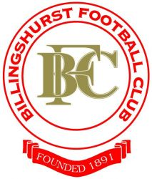

- The Club’s Management Committee will have the power to:

- Issue a verbal warning as to future conduct.
- Issue a written warning as to future conduct
- Oblige you to undertake an FA education course and asked to meet with the Committee.
- Suspend or have my club membership removed. (Including touchline ban or asked not to attend future games for a set period).
- Ask you to leave the Club along with any dependents.

To any person found to have broken the Club’s Policies or Codes of Conduct.

- Should any member wish to appeal against any decision then they must state their case in writing to the Committee within 14 working days.

